- Download and install Python 3.12.10 via https://www.python.org/downloads/release/python-31210/. Scroll down to find the “Windows installer (64-bit)” option
- Make sure to check these boxes when installing:

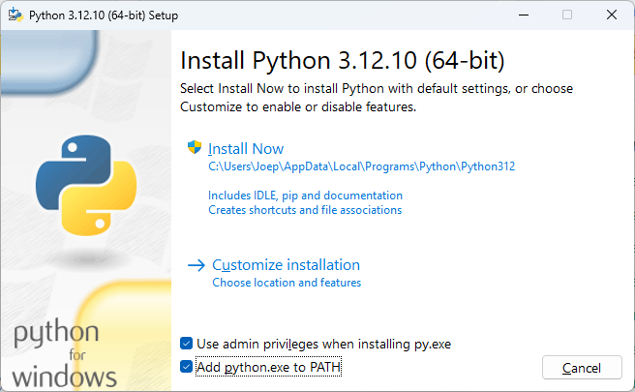

- Click on Install Now.
- Click on Disable path length limit:

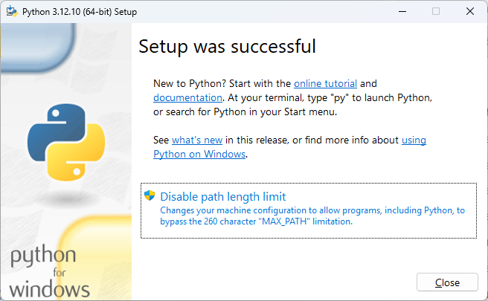

- Install Git via https://git-scm.com/install/windows
- Create a new folder in the file explorer where you want to clone the repository to. I’ll use the example “C:\ClinLine\cdisc_rules_engine”
- Enable case-sensitivity for this folder with Command Prompt:
fsutil.exe file SetCaseSensitiveInfo "C:\ClinLine\cdisc_rules_engine" enable
This should prevent you from receiving this warning:

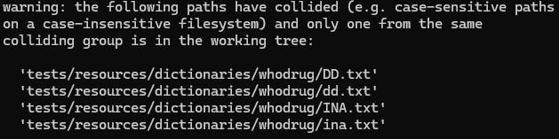

- Open Command Prompt and clone the repository to a location on your hard drive of your choosing:
git clone https://github.com/ClinLine/USDM_Core.git C:\ClinLine\cdisc_rules_engine
- Create a virtual environment for python for this project in the project folder with Command Prompt:
python -m venv "C:\ClinLine\VirtualEnvironment"
- Close Command Prompt and open PowerShell as administrator
- Make sure the execution policy of your computer is set to remote signed
Set-ExecutionPolicy -ExecutionPolicy RemoteSigned
- Activate the virtual environment in PowerShell:
C:\ClinLine\VirtualEnvironment\Scripts\Activate.ps1

PowerShell should now look something like this:
- Open the cdisc_rules_engine folder in PowerShell:
cd C:\ClinLine\cdisc_rules_engine
- Install the requirements:
python -m pip install -r requirements-dev.txt
- When it’s done installing the requirements, you can run a validation with a dataset in PowerShell:
python core.py validate -s usdm -v 4-0 -dp "C:\ClinLine\CDISC_Pilot_Study_v4_FIXED.json" -rt "Timeline","Test"
- To change the groupings of the rules, you can edit this file:
"C:\ClinLine\cdisc_rules_engine\resources\rules_with_tags.json"
You can add tags to rules and add new rules as you like. To run the validation with more than 1 tag, make sure to space them with a comma like in the example in step 15.
- When trying to run the validation with tags after the installation and after closing PowerShell, repeat steps 12, 13 and 15

